Easy Reads
Easy Read Zero Tolerance

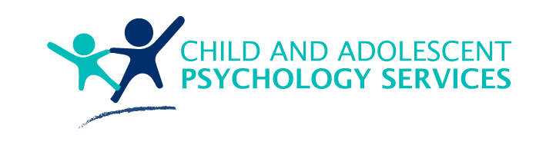 | When you see the words ‘we’ or ‘us’, it is talking about Child and Adolescent Psychology Services.
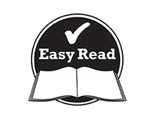 | This document is to help you easily understand the information.  Pictures are used to help explain.
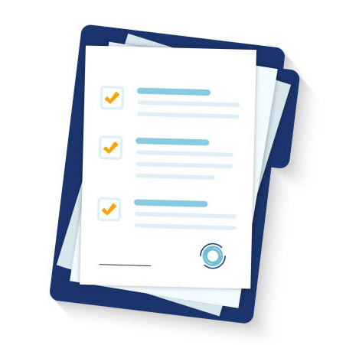 | This document is an Easy Read version of another document. You can also access this other document if you would prefer.
You can ask for help reading this document.
You can ask your family, friends, a support worker, or anyone else you would like.

About this document
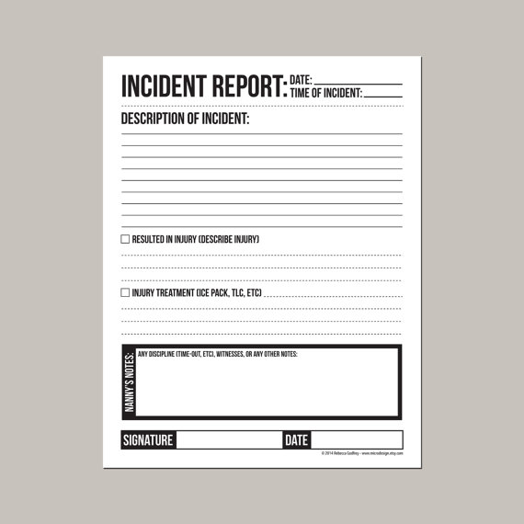 | This document tells you about how we try to prevent violence, abuse, neglect, and exploitation and how we manage it if it does happen.
What this means to you
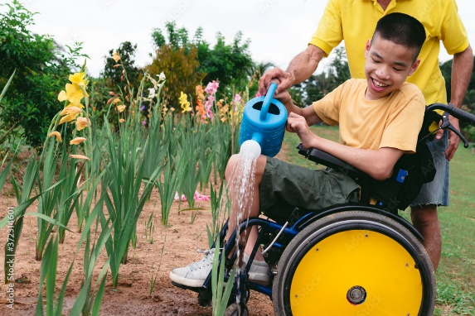 | You have a right to live your life free from violence, abuse, neglect, and exploitation.
 | We always want you to feel safe when you are receiving our supports.
 | If you don’t feel safe, please contact us immediately.
You can do this by:
- Talking to your support worker
- Calling us
- Sending us an email
What is violence, abuse, neglect, and exploitation
Violence is when someone hurts you physically.
Some examples are:
- Hitting
- Kicking
- Pushing
Abuse is when someone treats you badly. This can mean hurting your body or your feelings.
Some examples are:
- Hitting
- Yelling
- Saying things that hurt your feelings

Neglect is when someone is not caring for you or helping you when they are meant to.
Some examples are:
- Not feeding you enough
- Not helping you with personal hygiene (e.g., taking a shower)
Exploitation is when someone is taking advantage of you.
Some examples are:
- Using your money to buy things you didn’t agree to
Where to get help
 | We to not tolerate any acts of violence, abuse, exploitation, or neglect towards you.
 | We are here to help protect you and keep you safe.
 | So that we can help keep you safe, we want you to tell us if someone does hurt you or make you feel unsafe.
If you don’t feel comfortable calling us, please talk to someone you trust like:
- Your parents
- A sibling
- A carer
- Your support worker
- A teacher
 | Or you can tell us with the help of an advocate.
 | If you do want to use the help of an advocate, we can help you.
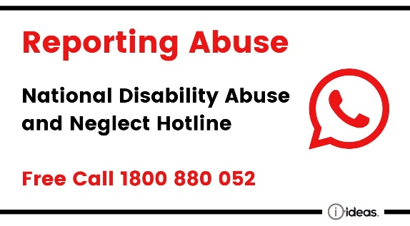 | You can also find help by contacting the National Disability Abuse Hotline.  Phone: 1800 880 052
To help keep you safe, we will:
- Make sure our workers are trained on how to handle incidents
- Make sure our staff know their responsibilities in keeping you safe
- Keep your information private
 | We will always support you if something bad happens.
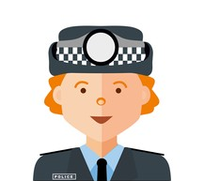 | Once we know about an incident of violence, abuse, exploitation, or neglect, we might need to call the police.  We do this so that we can help you out of an unsafe situation.
 | We will always:
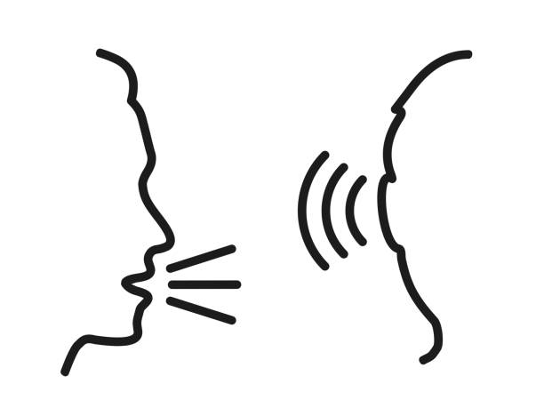 | - Listen to you and your advocate.
 | - Give you the help you need.
 | - Make sure you know what is happening.
If you aren’t happy with the results or how we handled the incident, you can contact the NDIS Quality and Safeguards Commission.
Email: contactcentre@ndiscommission.gov.au
Phone: 1800 035 544

Contact us
 | info@childandadolescentpsych.com.au
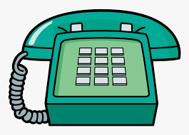 | 0416 101 019

