Easy Reads
Easy Read Rights

 | When you see the words ‘we’ or ‘us’, it is talking about Child and Adolescent Psychology Services.
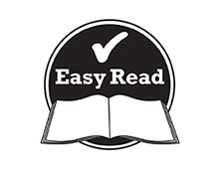 | This document is to help you easily understand the information.  Pictures are used to help explain.
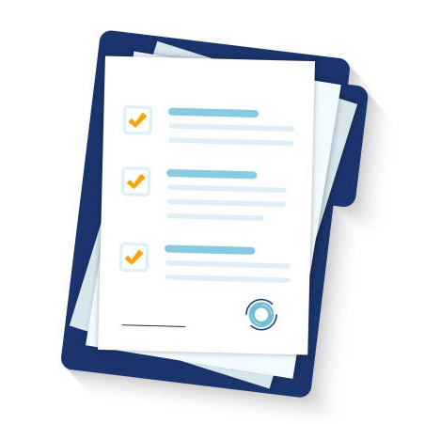 | This document is an Easy Read version of another document. You can also access this other document if you would prefer.
You can ask for help reading this document.
You can ask your family, friends, a support worker, or anyone else you would like.

Why we have this policy
 | This document is about Your Rights.
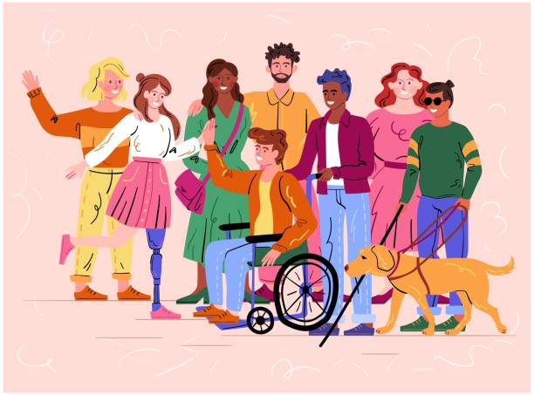 | There are laws that mean the rights of people with disabilities need to be respected.  You should be included in community life.  You have the same rights as everyone.
What are your rights?

 | - To receive good services
- To make your own choices.
You have control over your own life and the supports you use.
- To be safe.
No one is allowed to hurt you.
- To try new things.
Even if other people think it, isn’t a good idea.
- To get help for other people.
You can get help from your family or friends.
You can also get help from an advocate.
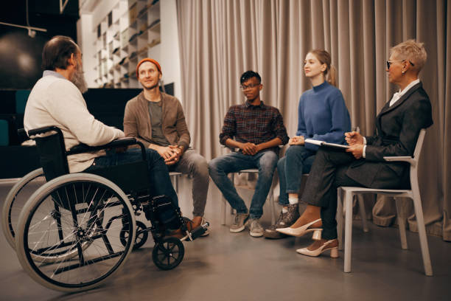 | - To work with other services so you can reach your goals.
 | - Make complaints
We should:
 | - Respect your privacy.
 | - Let you speak up.
 | - Respect everything about you, including:
 | - Your age.
 | - Your gender.
 | - Your religion, culture and beliefs
 | - Your sexuality.
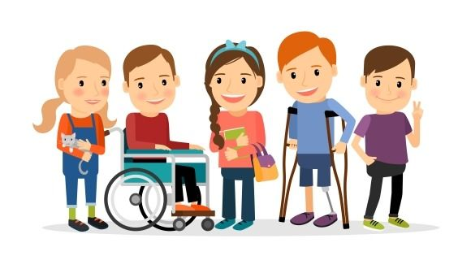 | - Your abilities.

Contact us
info@childandadolescentpsych.com.au
0416 101 019

