Easy Reads
Easy Read Privacy

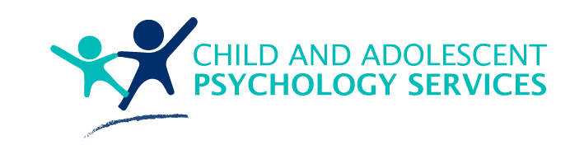 | When you see the words ‘we’ or ‘us’, it is talking about Child and Adolescent Psychology Services.
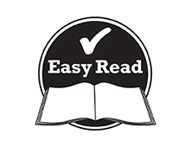 | This document is to help you easily understand the information.  Pictures are used to help explain.
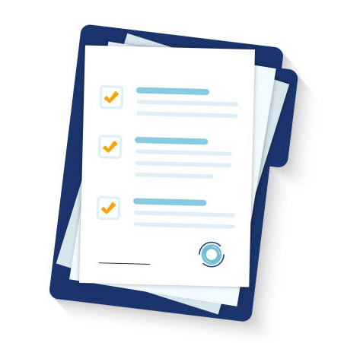 | This document is an Easy Read version of another document. You can also access this other document if you would prefer.
You can ask for help reading this document.
You can ask your family, friends, a support worker, or anyone else you would like.

Why we have this policy
 | This document explains that you will be treated with respect and your information will be kept safe and private.
 | We will explain your rights about your information
 | We will keep your information in a safe place.
We will only share your information if:
- You give us permission
Or
- We have to by law.
What is personal information?

 | Personal information includes your:
 | - Name and birthday
 | - Address, phone number and email address
 | - Bank account information
 | It also includes personal information about:
 | - Your medical records
 | - Your religious beliefs and practices
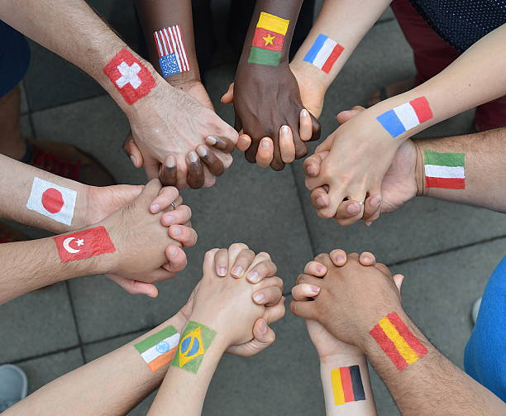 | - Your cultural background
This information is kept private so that it isn’t used to discriminate against or embarrass you.
Discrimination is when you are treated unfairly because of your race, beliefs, sexuality, or disability.
Your personal information is protected by law.
This law is called the Privacy Act 1988.
 | We can only collect information is you give us permission or if we are allowed to under law.
You do not have to give us your personal information.
But
If you don’t provide us with it, we may not be able to give you the best support possible.
What you can expect from us

 | We will explain what we do with your information.
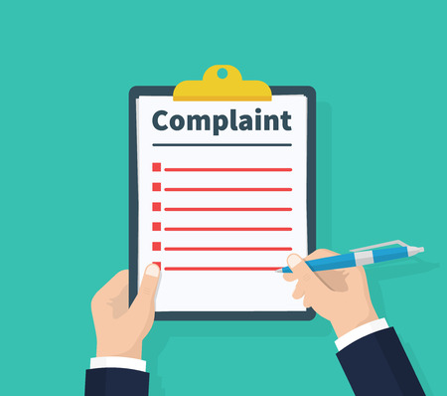 | We will also explain how you can make a complaint.
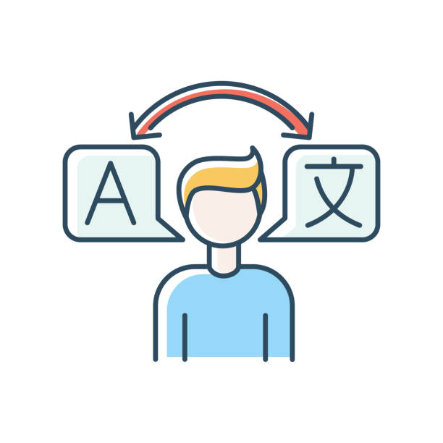 | We can find an interpreter if you need help understanding.
 | We will protect your information.
 | All our staff are trained to understand their role in protecting your information.
How information is collected and used
 | We collect your personal information when it is needed for:
 | - Managing a complaint.
 | - Organizing services outside of CAPS.
 | - Deciding the best supports for you.
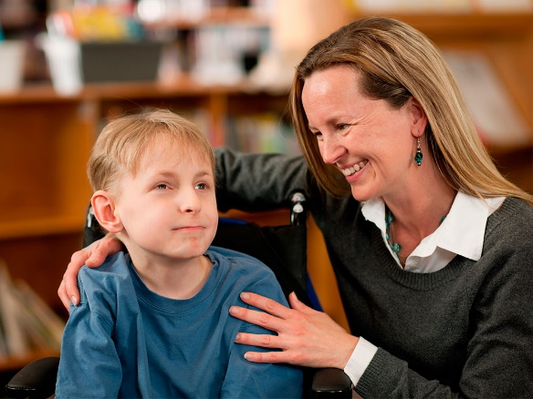 | We collect this information directly from you or your legal guardian.
 | Sometimes we can collect information from the government or other organisation that provide you with support.
Sharing your information with other people

 | We might need to share your information with other people so you can receive services.
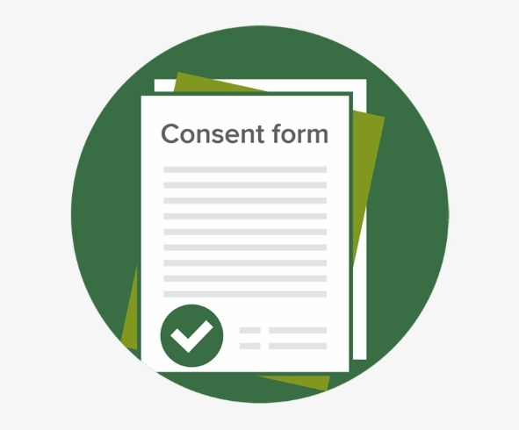 | There is a Client Consent form that you will be asked to sign before you start receiving our services.  This consent form will authorize us to share your information with another organisation that support you.
 | This is so that all the organisations working with you can discuss how to give you the best support.
Sometimes we will share your information with another organisation even if you have said no.
This is only when we think that someone is not safe or if we think a crime has been committed.
How we protect your information

 | We have a lot or strategies to make sure your information is safe and secure.
Some information is paper.
We keep this in a locked filing cabinet.
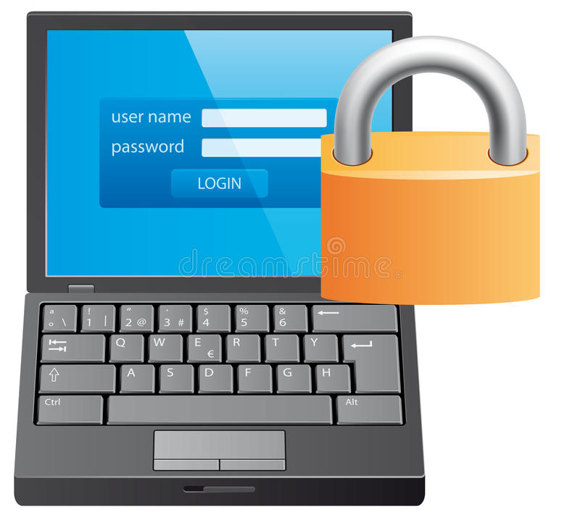 | Other information is digital.  This information is kept in a strongly protected computer program.
 | If your information is lost, stolen or has been provided to someone who was not approved, and we think this could put you at risk, we will tell you about it.
 | If you’re under 18 years old, we will keep your information until you turn 25 years old. Otherwise, we will keep the information for 7 years after you leave our services.
Accessing your personal information

 | If any of your information changes, please let us know.
 | If you would like to see your personal information, you can contact us using the information at the end of this document.

Contact us
 | info@childandadolescentpsych.com.au
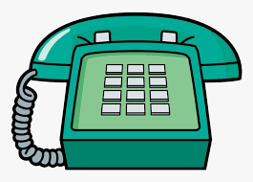 | 0416 101 019

