Easy Reads
Easy Read Complaints and Feedback

 | When you see the words ‘we’ or ‘us’, it is talking about Child and Adolescent Psychology Services.
This document is to help you easily understand the information.
Pictures are used to help explain.
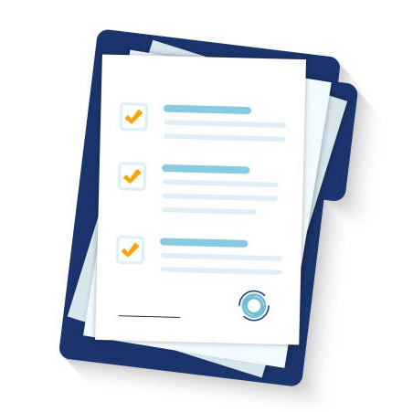 | This document is an Easy Read version of another document. You can also access this other document if you would prefer.
You can ask for help reading this document.
You can ask your family, friends, a support worker, or anyone else you would like.

About this document

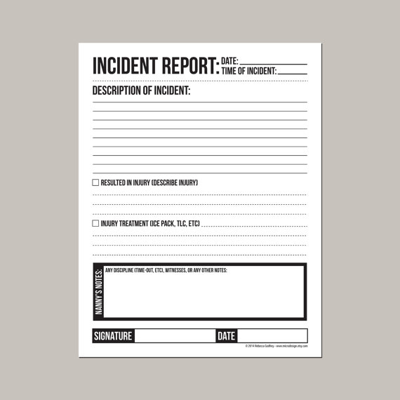 | This document explains how we respond to and resolve incidents.
This document will help you understand:

- How to recognize an incident
- How to get help
- How we respond to incidents
- What information we need from you
- How we can help you if you are involved in an incident
What is an incident?
- A time you are harmed by an organisation or their workers
- A time when you could have been harmed by an organisation or their workers
- A time you hurt someone else
- When someone else feels like you are going to hurt them
- A reportable incident (death, serious injury, abuse, neglect, sexual misconduct, restrictive practices)
 | Some examples of incidents are:
 | - A person experiencing harm or abuse
 | - Lost or broken property
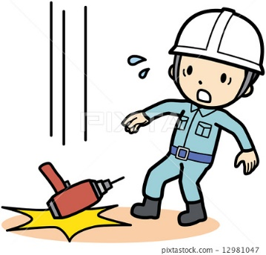 | - A situation where you were nearly harmed
 | - Someone giving you the wrong medication
 | - Changes to your support routine that cause harm to you
- Illegal activities
(e.g., theft, drug use)
How to get help
You can report an incident to us at any time.
Reporting is when you tell us about an incident you have experienced or an incident you think someone else has experienced.
We will help you through the reporting process.

 | Family, carers, friends and advocates can also help you report an incident.
You can report an incident by:
- Telling your support worker
- Sending us an email
- Calling us on the phone
How we respond to incidents
 | Once we know about the incident, we respond as soon as possible. We will let you know when and how we will respond.
 | Our workers are trained to know how to respond to incidents.
 | Incidents that are less serious will be handled by us. We will talk to you and other people involved to help us solve the problem.
Reportable Incidents
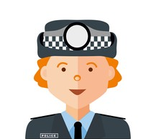 | When an incident is more serious, we need to notify the Police and the NDIS Quality and Safeguard Commissioner.
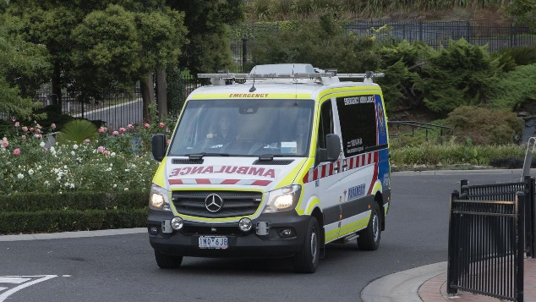 | An example of this is if you are badly hurt while under our care.  This is called a Critical or Reportable Incident.
What Information do we need?
When we are resolving an incident, we keep records.
This is when we write down what happened and what we did to help fix it.
 | We record what was said and done during the incident including:
- What happened
- When it happened
- Who was involved in the incident
- Who saw the incident
- When you told us
How will we help you?
 | You are important to us, so we:
- Assist and support you
- Help you feel safe
- Look after your physical health and your mental health
We will listen to you when you tell us what happened.
We will talk to you and anyone supporting you about you to fix it.
 | We know how important you are in helping us fix the problem so we:
- Ask you for feedback
- Talk to you about what happened
- Explain the process to you and anyone helping you (e.g., family, friend, carer or advocate)
- Consider ideas you have to make positive changes
 | If we make changes to correct what happened, we will:
- Change our practices
- Changes our policies and procedures
- Give more training to our workers

If you aren’t happy with the results or how we handled the incident, you can contact the NDIS Quality and Safeguards Commission.
Email: contactcentre@ndiscommission.gov.au
Phone: 1800 035 544

Contact us
 | info@childandadolescentpsych.com.au
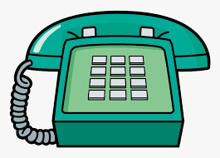 | 0416 101 019

