Easy Reads
Easy Read Complaints and Feedback

 | When you see the words ‘we’ or ‘us’, it is talking about Child and Adolescent Psychology Services.
This document is to help you easily understand the information.
Pictures are used to help explain.
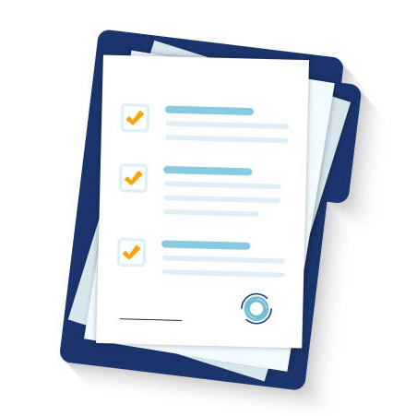 | This document is an Easy Read version of another document. You can also access this other document if you would prefer.
You can ask for help reading this document.
You can ask your family, friends, a support worker, or anyone else you would like.

What is this document about?
This document explains how we handle feedback and complaints.
Feedback
Feedback is when:
- You tell someone about a problem
- They fix it quickly
You can also tell us when you think something is going well.
That is positive feedback.
Complaints
A complaint is when you tell someone:
- Something has gone wrong

- Something is broken

Complaints are more serious than feedback.

This document explains:

- How to make a complaint
- What we will do about your complaint
We want to make sure everyone is treated fairly.
We want you to tell us what you think.
Your opinion is important to us.
Your opinion helps us:
- Make our services better
- Help everyone feel safe
When we are handling complaints, we need to show respect for everyone.
Please tell us if you need:
- An interpreter – someone who speaks your language
- Information in a different format
How to make a complaint
If you have a complaint, you can tell your Support Worker.
They will try to do something about your problem.
If they can’t fix the problem easily, you can fill out a Feedback and Complaint Form.
When you’re making your complaint, you can ask for help from an advocate.
An advocate is someone who helps you speak up.
Fill out our Complaint Form
When you fill out a Complaint Form, you are making a formal complaint.
Formal complaints are taken very seriously.
When you make a formal complaint, we keep a record in our files.
Your complaint will be given to our manager.
The manager will:
- Read your complaint
- Contact you to try to fix your complaint
When your complaint has been fixed, we will keep a record of:
- What your complaint was
- How we fixed it
If the manager can’t fix the problem, it will be given to our CEO.
This is the person in charge of our organisation.
If you aren’t happy with the results of the complaint, you can contact the NDIS Quality and Safeguards Commission.
Email: contactcentre@ndiscommission.gov.au
Phone: 1800 035 544

Contact us
info@childandadolescentpsych.com.au
0416 101 019

